**Tragic Bus Collision in Kurunegala:**

**Four Dead, Driver Arrested**

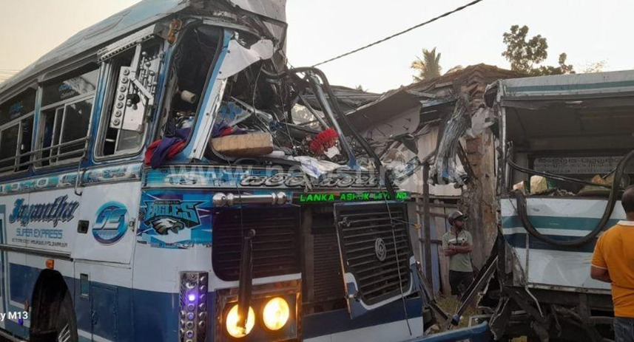*10-02-2025 | 8:44 AM*

COLOMBO (News 1st); A bus driver has been arrested in connection with a collision that occurred in Thorayaya, Kurunegala, early on Monday (10) morning. According to police reports, the driver was apprehended while attempting to flee the scene.

The accident took place this morning when two buses, one traveling from Maduru-Oya to Colombo and the other from Kanduruwela to Kurunegala, collided. The impact resulted in the deaths of four individuals and injuries to 20 others.

A spokesperson from the Kurunegala Hospital stated that the condition of four of the injured is critical. The collision occurred when the bus traveling from Maduru-Oya to Colombo rear-ended the bus that was parked in Thoranaya, which was en route from Kanduruwela to Kurunegala. Among the deceased are three men and one woman.